Chris,

You said that I need to ensure that my category codes are sequential integers up to the number of categories and that my missing value code matches that expected by Realcom-Impute.

This is the frequency of the dependent variable. As shown below, it has sequential integers.

c_race | Freq. Percent Cum.
------------+-----------------------------------
1 | 89,344 10.35 10.35
2 | 462,759 53.60 63.95
3 | 23,287 2.70 66.65
4 | 1,536 0.18 66.83
5 | 11,581 1.34 68.17
. | 274,816 31.83 100.00
------------+-----------------------------------
Total | 863,323 100.00

Let me add what I have done at STATA step:

Using STATA, I ran this:

xtmixed c_race im_mc_p_black im_mc_p_white im_mc_college || fips_code:
gen cons=1
sort fips_code
realcomImpute c_race im_mc_p_black im_mc_p_white im_mc_college using cmInputs.dat, replace numresponses(1) level2id(fips_code) cons(cons)

Is there anything wrong above?

Using RealCome:

- Click “open data file”

- Click “specify type of responses” and set up as shown below:
The dependent variable is unordered categorical variable. Thus, I clicked “un-ordered category” & changed “set # of categories” to 5. See the red-circled parts.

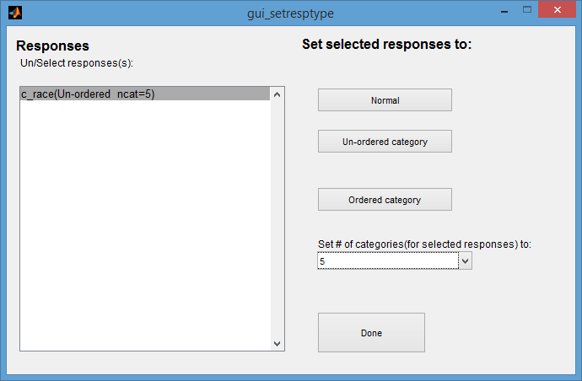

Then, I got an error, as shown below:
As you said, max observed category > specified in NCATS for variable 1", which will prevent it from running any further.
However, when I set up like the screen shot below, it worked.
I clicked “Normal” & changed “set # of categories” to 5. See the red-circled parts.

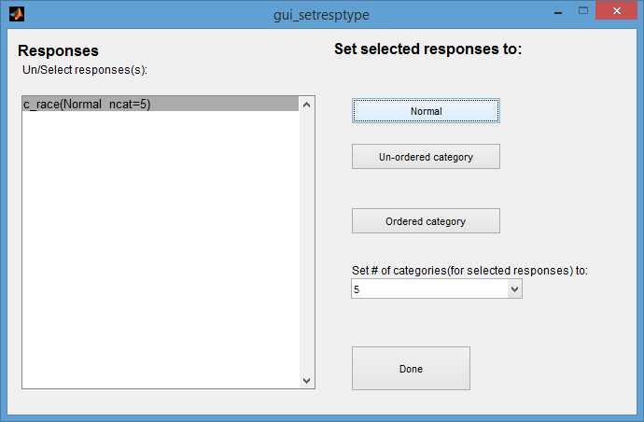

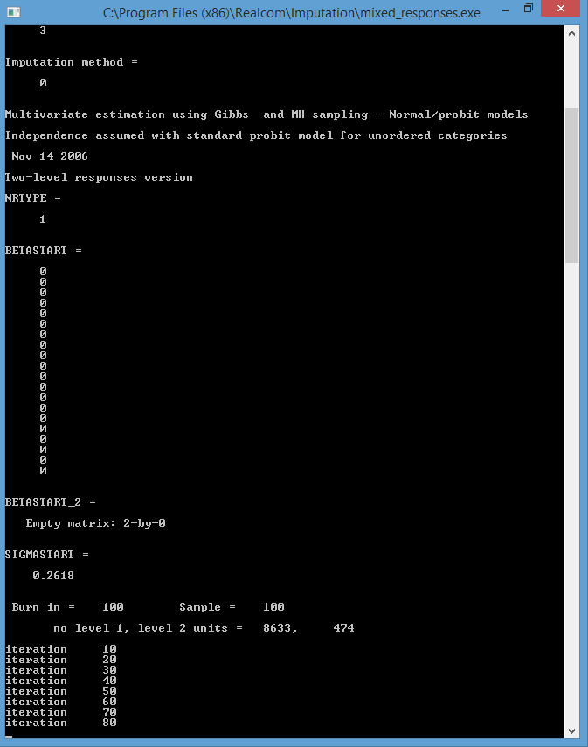
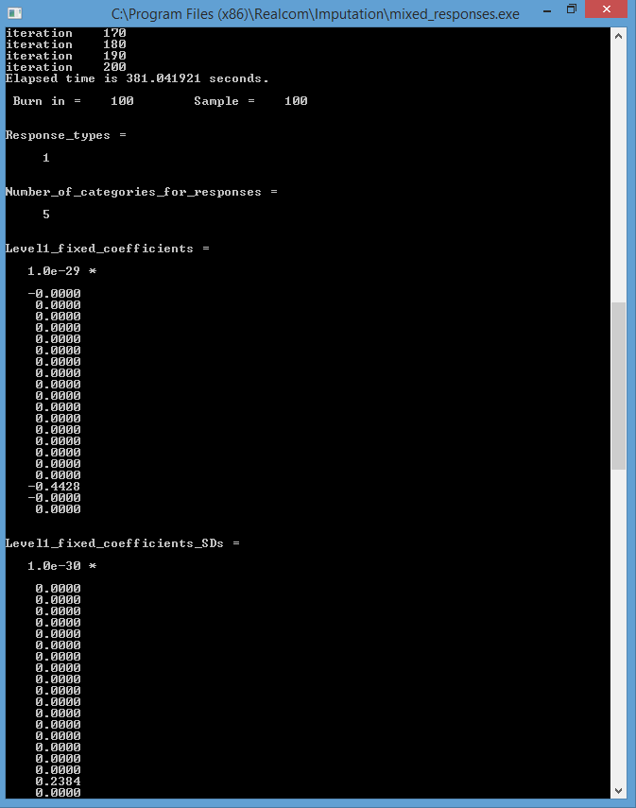

However, its imputed data for the categorical variable, which ranges from 1-5, have negative values.
This is the original variable with missing
Variable | Obs Mean Std. Dev. Min Max
-------------+---------------------------------------------------------
c_race | 5,851 1.948727 .6273834 1 5
c_race1 | 8,633 1.880312 .8192517 -6.2732 7.0772
c_race2 | 8,633 1.888451 .8079148 -5.0789 6.4309
c_race3 | 8,633 1.892885 .7927905 -5.9833 6.2303
These imputed variables have negative values.
c_race4 | 8,633 1.887415 .8138647 -6.5342 6.0595
-------------+---------------------------------------------------------
c_race5 | 8,633 1.896017 .8046088 -6.0903 6.0418
c_race6 | 8,633 1.880791 .8273373 -5.8956 5.6657
c_race7 | 8,633 1.886135 .8198552 -6.5697 5.2372
c_race8 | 8,633 1.881411 .8277196 -6.5855 5.7724
c_race9 | 8,633 1.876426 .8565076 -5.6032 7.1435
-------------+---------------------------------------------------------
c_race10 | 8,633 1.869398 .853488 -6.3677 6.4568

What should I do to impute a categorical variable?

